City of Charleston
MWBE Certification

This is to certify that

Seacoast Supply, LLC

Has met the requirements and is re- certified minority or woman-owned business enterprise in good standing with the City of Charleston, South Carolina’s Minority and Women Business Enterprise Program.

July 30, 2020 06-073020-254 August 30, 2022
Date of Certification Certification Number Expiration Date

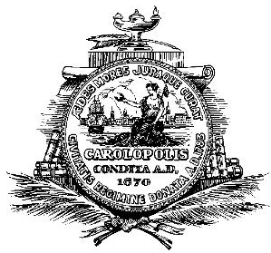

Ruth M . Jordan ___________________
MBE Manager

